第三次上机：构造函数和析构函数
程序代码：
#include<iostream>
using namespace std;
class Score {
public:
Score()
{
Students = 2;
}
Score(int number)
{
Students = number;
}
~Score()
{
}
int i = 1;
void getgrade()
{
for (i = 1;i <= Students; i++) {
cout << "请输入学生姓名：" << endl;
cin >> name[i];
cout << "请输入科目A的成绩：" << endl;
cin >> a[i];
cout << "请输入科目B的成绩：" << endl;
cin >> b[i];
cout << "请输入科目C的成绩：" << endl;
cin >> c[i];
}
}
void showgrade()
{
for (i = 1;i <= Students;i++)
{
cout <<"姓名："<<name[i] << "科目A的成绩：" << a[i] <<" " << "科目B的成绩：" << b[i]<<" " << "科目C的成绩：" << c[i]<<" " << endl;
}
}
void showavgstu()
{
for (i = 1;i <= Students;i++)
{
cout <<name[i]<<":" << ((a[i] + b[i] + c[i]) / 3);
}
}
void showclassgrade(char f)
{
float avg = 0;
if (f == 'a')
{
for (i = 1; i <= Students;i++)
{
avg = avg+a[i];
}
avg = avg / Students;
cout << "课程名称:A" << "平均成绩:" << avg << endl;
}
if (f == 'b')
{
for (i = 1; i <= Students;i++)
{
avg = avg + b[i];
}
avg = avg / Students;
cout << "课程名称:B" << "平均成绩:" << avg << endl;
}
if (f == 'c')
{
for (i = 1;i <= Students;i++)
{
avg = avg + c[i];
}
avg = avg / Students;
cout << "课程名称:C" << "平均成绩：" << avg << endl;
}
}
private:
int Students;
float a[100], b[100], c[100];
string name[100];
};
int main()
{
Score A;
A.getgrade();
A.showgrade();
A.showclassgrade('a');
A.showavgstu();
return 0;
}
程序结果：
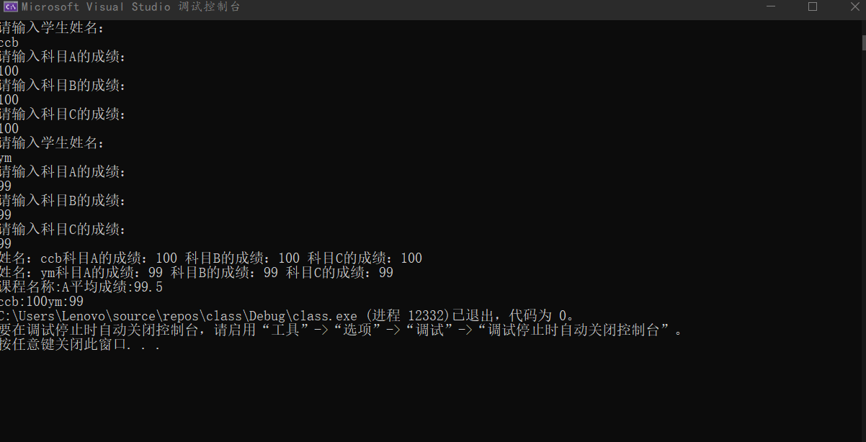
感想心得：
在处理这个程序的时候，由于涉及到多个学生的姓名与成绩还有一系列的运算，如：学生的平均成绩、课程的平均成绩等等，使我最开始有些没有思绪。后来经过思考我大致有了两个方向。一是通过多个数组来储存不同学生的成绩，然后通过成员函数对其进行运算；二是通过多维数组对其进行储存然后再运算。在这里我选择了通过多个数组进行存储。

